Prompts for different purposes
Effective prompting can help guide an AI tool to generate useful output for a variety of tasks, from content creation to problem solving. In this reading, we provide some examples demonstrating how to use the prompting framework—Task, Context, References, Evaluate, Iterate—to get reliable and useful results in different cases.
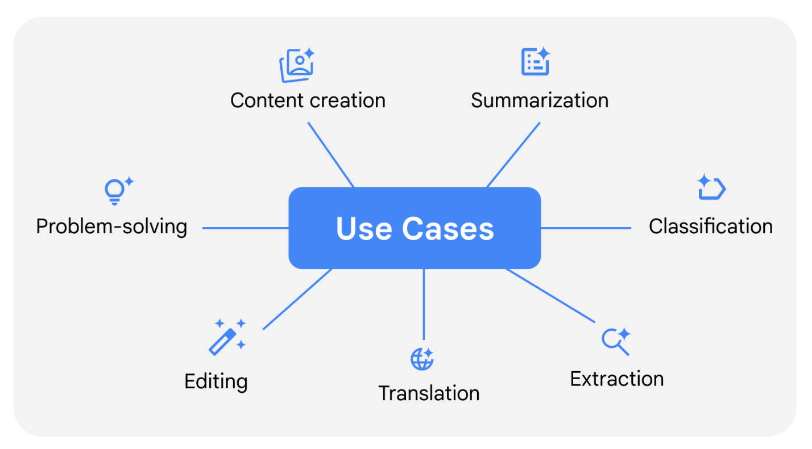

Content creation
AI tools can generate a wide range of content, no matter your industry or role. You can use AI tools to help you create content like images, videos, documentation, and code. When prompted effectively, AI tools can help you spark creative ideas while saving time.
Here's a sample prompt that incorporates prompting best practices by including a specific task, context, and references:
Act like you are a creative advertising professional who can apply innovative thinking to develop original taglines that highlight the positive qualities of a product. Create a concise tagline for a washing machine that gets clothes extra clean, has 25 settings, and fits in a small space. The tagline should use an active voice, and be no more than 6 words. Refer to these examples of successful taglines in this industry, which emphasize efficiency and convenience.
- Reference #1: "Less soap. More clean."
- Reference #2: "Transform laundry into pure magic."
This prompt clearly states that the task is to create an original and concise tagline. It also provides necessary context by specifying the tone, style, and format of the tagline. The references include examples to help guide the AI tool's output.
Pro tip: Learn more about how you can use Gemini as a creative partner.

Summarization
AI tools can quickly process and condense large amounts of text while preserving key pieces of information—making them ideal for distilling complex information into clear, concise highlights.
Here's a sample prompt that incorporates task specifics, context, and format preferences:
Summarize the following email from a software vendor. Create a concise, professional overview that includes a bulleted list of each paid subscription tier with its benefits to clients. The summary should be easy for a sales representative to quickly review before following up with the potential client.
[Email content would follow here]
This prompt demonstrates how specifying your style, tone, and format preferences can help generate summaries tailored to a specific audience's needs—ensuring the output is useful and relevant.
Pro tip: Learn more about how you can use Gemini to summarize meetings.

Classification
AI tools can help you analyze and categorize content like service emails and customer reviews based on specific criteria. This feature can help you sort through information and organize it into meaningful and actionable insights.
Here's a sample prompt that specifies a task, provides clear classification criteria, and includes references:
Analyze these customer reviews and tell me whether the sentiment of the reviews is positive, negative, or neutral. For each review, provide a one-sentence explanation for the classification based on these criteria:
- Positive: Consistently favorable comments or mostly positive with minor criticisms
- Neutral: Mixed or balanced positive and negative comments
- Negative: Consistently unfavorable comments or mostly negative with minor positive elements
- Review #1: I don't know where to begin. We had reservations for 7:00 but they seated us at 7:45. Then, no one came to our table for at least 30 minutes. Our appetizer and main course were mediocre. I did love the dessert, but that wasn't enough to change our experience.
- Review #2: I love this restaurant. The food is delicious and the service is excellent.
This prompt begins by clearly stating that the task is to analyze the sentiment of a customer review and then specifies the options: positive, negative, or neutral. By clearly defining each category, the AI tool can make more accurate assessments and generate more consistent results.

Extraction
AI tools can save you time by quickly gathering exactly the information you need from large, complex documents. This could be numbers from financial reports, product details from catalogs, or key points from meeting notes. To achieve more precise results, you can use the verb "extract" in your prompt, along with clear instructions about the type of information you need and how you want it formatted.
Here's a sample prompt that incorporates task specifics, relevant context, and format preferences:
I'm planning our department's clothing budget and need to track pricing trends. Extract all of the references to items of clothing I can buy and how much each item costs from the blog post below. Create a spreadsheet of just these items. Format the output with two columns labeled "Item" and "Price." Capitalize list items and organize them by price from high to low.
[Blog post content would follow here]
This prompt begins by clearly stating that the task is to extract all the items of clothing mentioned in the blog with their corresponding prices. It also specifies that the data should be organized in a spreadsheet, with clear formatting instructions—preparing the data for quicker analysis.

Translation
AI tools can help facilitate communication by translating content for global audiences, making it easier to communicate with international colleagues and create multilingual content.
Here's a sample prompt that incorporates task specifics, context, and style preferences:
We're a boutique bike shop that sells cycling and outdoor adventure gear. Translate our product descriptions from English to Dutch. Maintain the same structure and casual tone that is used in the English version in the Dutch translation. Consider cultural context and ensure the expressions maintain their marketing appeal in Dutch.
- Reference #1: Whether you’re exploring city streets or forest paths, our sleek and durable bicycle has it all.
- Reference #2: Roll into summer in style with our smooth and stylish rollerblades.
This prompt begins by clearly stating that the task is to translate product descriptions from English to Dutch. It also specifies that the Dutch translations should maintain a similar structure and tone as the English originals, ensuring the tool generates output that resonates with the target audience while staying true to the original content's intent.

Editing
AI tools can help refine and improve existing text to ensure clear communication. Using specific editing instructions helps AI tools make appropriate adjustments while preserving the original message.
Here's a sample prompt that incorporates task specifics, context, and audience needs:
As the communications manager for a manufacturing company, I need to explain our site selection process to local community stakeholders. Rewrite this text for a non-technical audience. Simplify the language while keeping all the main ideas intact.
[Text content would follow here]
This prompt demonstrates how specifying your task and the target audience can lead to more useful revisions when editing text. By clearly stating what needs to be simplified, the AI tool can make appropriate changes while maintaining the core message.

Problem-solving
AI tools can also help you break down complex challenges and quickly come up with potential solutions. When using AI for these kinds of tasks, breaking your request into manageable steps can help to produce better results.
Here's a sample prompt that demonstrates how to structure a complex problem:
We are running a community program to teach children gardening skills. The program runs from June 1 to August 15. We want the children to be able to grow plants that will be ready for harvest by the time the program ends. First, identify a list of 10 plants that can be planted and grown in that time period. Include sources that support the time to harvest for each plant.
Next, choose three plants from the list that will provide the children with the most variety. We want the children to grow three plants that are as different from each other as possible.
This prompt begins with useful context about the program, such as its main purpose and timeline. It also breaks down what would otherwise be a complex task into manageable steps. As with any other use case, applying effective prompting techniques and adjusting them to fit your specific needs is the key to getting reliable and useful results from AI tools.
The examples in this reading demonstrate how your prompting approach should be adapted for different workplace tasks. While each use case can require specific techniques, the core principles remain the same—Task, Context, References, Evaluate, Iterate. With practice, you can become more skilled at crafting prompts for any situation and get the exact output you need.

